Report for Stapleford Parish Council:

South Cambridgeshire District Council – June 2020

1. Greater Cambridge Local Plan
The thousands of people who took part in a recent consultation on the future of Greater Cambridge are being thanked by councils – as a report published on Friday May 22nd sets out that the consultation ‘reached more residents than ever’.
1.1 The seven big themes
From the circa 7,000 comments received, which the councils are still in the process of analysing, the Initial Feedback from the Consultation identified some key areas to be explored during the development of the Local Plan:
- On where to build, it appears there is support for densification of existing urban areas, along with development along public transport corridors. Views on development around villages were polarised and, on green belt development, it appears there is some support for locations which are sustainable in transport terms, to reduce car travel from locations further away
- Most people agree that the right seven themes have been identified for the Plan, but there was a range of views about which themes should take priority
- Infrastructure – which can refer to road and cycle networks, education and health provision, and more – was the theme that attracted the most interest, by a substantial margin, with transport being the most commented on topic
- The second most popular theme was homes, followed by climate change, which prompted a wide range of views – from those who felt it was a high priority, to those who felt that other issues should take precedence
- Many responses said that continuing economic growth was important, although many also raised questions around whether growth was desirable. Some stated that wellbeing was a priority over growth, while others expressed the view that economic growth was the means to raise quality of life.
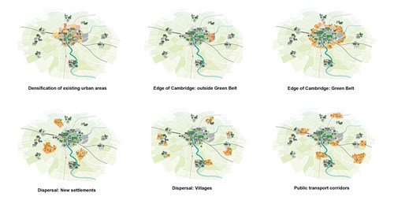

1.2 Options put forward for where to build
The report, published for the meeting of the Joint Local Planning Advisory Group on 2 June, also outlines a proposed timeline for the next stages of the Local Plan process, which takes into account the comments received and the clear aspiration for continued involvement by communities in the early stages. The new programme outlined in the report makes arrangements to do so, and includes:
- publishing emerging evidence from commissioned external experts in October 2020, followed by stakeholder engagement workshops to debate these in November/December
- the first key milestones for public participation in the plan in summer 2021, when members of the public will be asked to input into the proposed approach. This will be the ‘Preferred Options’ stage, which sets out specifics such as proposed levels of development for jobs and homes; sites allocated for development; and the preferred approach for key policy topics such as climate change targets, affordable housing thresholds, and approach to development in villages.
The proposed timeline is subject to approval by councillors during June 2020.
The report can be viewed on the website. The Greater Cambridge Planning Service is a partnership between Cambridge City and South Cambridgeshire District councils, and updates on the Local Plan process will be available at www.greatercambridgeplanning.org

2. COVID19 Lockdown
The South Cambs office is still on lockdown and officers are working from home still. We have no immediate plans to re-open the offices, but as you know, the situation may change as we get more guidelines from Government.
However residents can continue to have access to our services online at www.scambs.gov.uk:

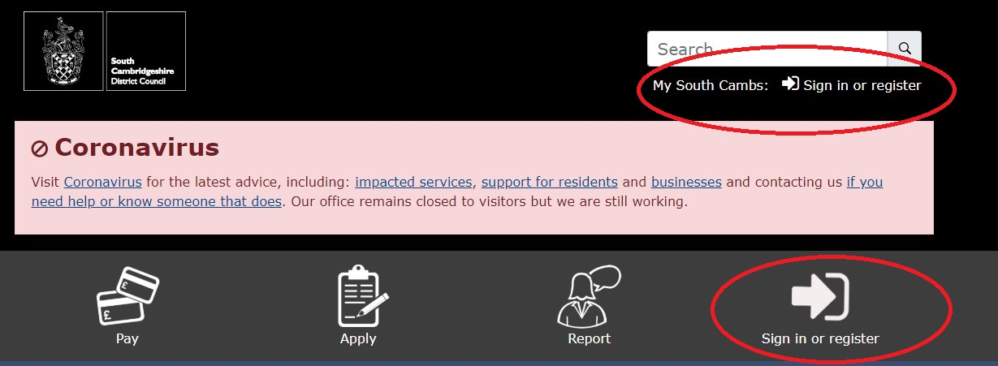

3. Zero Carbon Strategy
Our Zero Carbon Strategy was adopted by the Council on 21 May 2020. It outlines how we are supporting the district to halve carbon emissions by 2030 and reduce them to zero by 2050, including delivering a reduction in our own carbon footprint of at least 45% by 2025, (on a 2019 baseline), and at least 75% by 2030. Find out more at https://www.scambs.gov.uk/council-adopts-zero-carbon-strategy-for-south-cambridgeshire/
4. Business Grant Funding
On May 13th the Government announced a further ‘discretionary’ business grant scheme which in South Cambs will be c £1m. Eligible businesses such as charities, market traders, B&Bs and those in shared offices or flexible workspaces are invited to apply as soon as possible for the new funding, and no later than midnight on 22 June.
Applications should be made online at:
https://www.scambs.gov.uk/business/coronavirus-information-for-businesses/financial-support-for-business/discretionary-grant-funding/
Whilst this is a discretionary scheme for local authorities to deliver, many of the criteria have been set nationally, including the priority areas below. In response to the leader’s comments that some of these categories are not a priority for us, we sought guidance from BEIS who responded as follows: “To summarise, funding should be focused primarily on those categories listed but we accept that a proportion of it won’t be used on those and it is for the LAs to decide who in that group they think are the most needy. So effectively we need to include the following categories, but can decide on the amounts we award per category, and we can add extra categories.”
Categories identified by government:
· Small businesses in shared offices or other flexible workspaces. Examples could include units in industrial parks, science parks and incubators which do not have their own business rates assessment.
· Regular market traders with fixed building costs, such as rent, who do not have their own business rates assessment.
· Bed & Breakfasts which pay Council Tax instead of business rates; and
· Charity properties in receipt of charitable business rates relief which would otherwise have been eligible for Small Business Rates Relief or Rural Rate Relief.
In addition to these priorities, the government guidance sets out a number of eligibility criteria, including:
· A rateable value or rent or mortgage of less than £51k
· Ineligible for other current schemes, such as Retail, Hospitality and Leisure Discount and the first round of Small Business Grants
· Turnover is not more than £10.2m
· Balance sheet total is not more than £5.1m
· Less than 50 employees
· Must have relatively high ongoing fixed property related costs
· Must be able to demonstrate a significant fall in income
· Must have been trading as of 11th March 2020 (any company in administration or insolvency is excluded)
· Charities must have a rateable value of less the £15k and must not already receive Small Business Rate Relief.

Please contact District Councillors Nick Sample or Peter Fane if we can help with local council matters.

Cllr.sample@scambs.gov.uk Mob. 07706 990833
Cllr.fane@scambs.gov.uk Mob. 07802 256861

