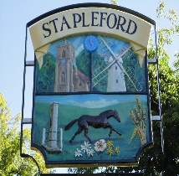 | Stapleford Parish Council  CLERK Belinda Irons  14 Crawley End, Chrishall, Nr Royston, Herts, SG8 8QL  M:07840 668048 e-mail – clerk@staplefordparishcouncil.gov.uk
Cambridge South East Transport 7th December 2020
Cambridgeshire County Council
Business Intelligence Service
OCT 1224
Castle Hill
Cambridge
CB3 0AP
Dear Sirs
Cambridge South East Transport: Stapleford Parish Council response to the Environmental Impact Assessment Consultation
Stapleford Parish Council wishes to respond to the Environmental Impact Assessment consultation provided on the GCP website.
Process
GCP has put the cart before the horse in leaving an environment assessment until after it has chosen a route. GCP has not undertaken an EIA as part of its assessment of route options and therefore cannot be inviting comments on it as part of this consultation. GCP has thus placed itself in a situation where, having spent a great deal of money on developing one option, it will be unviable if the environmental assessment is negative to the extent that GCP is forced to abandon this single option. In this circumstance, GCP has no incentive to undertake the environment assessment with the diligence and independence of mind that the importance of the subject deserves.

Respondents are being asked to comment on the minutiae of how GCP plans to mitigate 'possible impacts on the environment'. This consultation has very little reference to the massive impact on Stapleford and Great Shelford and the Green Belt and indeed the route through Stapleford is not identified in the questions.

It is recognised that the GCP have regularly announced their plans but have never consulted on a choice of offroad route. Consultation such as it has been has been carried out without recognition of the valid concerns raised and in particular that a less environmentally damaging route is available and fully feasible.
The alternative railway alignment route.
Stapleford and Gt Shelford Parish Councils have commissioned an independent report from transport consultant iTransport. This concludes that the Shelford railway alignment route ‘is a technically feasible alternative to the preferred route’ and demonstrates that the criteria for the chosen route are invalid and demonstrates a failure of process.

Sustainability and multi modal transport
In undertaking the assessment, GCP's modelling should be informed by the strategic principles that GCP claims inform its policies and their decisions. These principles include sustainability, reduction of congestion and pollution and the offer of multimodal travel.

The concept of CSET involves building a 2,000 space car park which will act like a magnet drawing people into their cars from the surrounding villages and towns and thus reducing the viability of local public transport. Instead of enhancing sustainability a 20th Century Park & Ride scheme is being developed which offers a more regular system of travel when compared to the existing services. Rather than reducing car travel it increases car travel and carbon.

In reality, GCP's chosen route will also transfer much of the congestion and pollution on the largely rural A1307 to the residential villages of Stapleford and Great Shelford, with a significant detrimental impact on air quality, congestion, ease of vehicular movement, noise, parking, and the local street scene. This detrimental impact will be caused by two factors, firstly with fly parking around the bus stops on country lanes: commuters will want to drive from the surrounding villages to as near to Cambridge as possible to pick up the bus, and secondly by the extra crossings on all three roads with traffic lights giving bus priority and causing vehicles to queue on these three roads. GCP have offered no pollution checks to counter this or any option of an audit.

Damage to the Environment
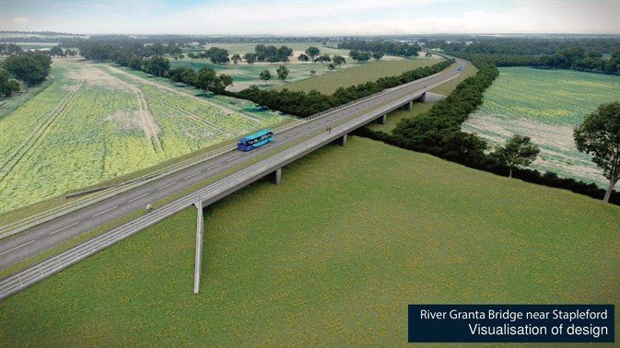
The proposed busway carves a 14m strip of tarmacadam across the fields adjacent to the Magog Down, a unique Cambridge environment and destroying the Green Belt. This is a special landscape and identified as such for preservation in the 2003 Cambridge Landscape Character Assessment, Section 2.2-2.3: ‘The chalklands to the south east rise to 70m at Wandlerbury, and from which there are extensive views of the city and surrounding countryside. The high ground and open countryside close to the city is a highly valued resource…. Amongst the most important features of Cambridge are the green fingers and corridors… including the Vicar’s brook and Hobson’s Brook corridor extending from Nine Wells area to the south of the city, north through Empty Common to the river Cam’

The Down plays an important part in the setting of both Stapleford and Cambridge and contributes much to the physical and mental health of many people. Seeing a tarmac Busway 14 metres wide and a bus every four minutes cutting through this landscape, bus stops that look more like bus stations, and two brutally grotesque bridges across the picturesque River Granta will all create irreversible damage.
Biodiversity
The Magog Down is a chalk grassland restoration site and would now meet the criteria for Local Wildlife Site status and should be included in the list of non-statutory sites for nature conservation. This also includes the Stapleford Parish Pit.
There is insufficient information contained in the documentation to make a serious assessment of the environmental impact of the scheme. It is lacking in detail particularly regarding mitigation for key species and other important species not considered such as insect habitat which supports all life, with broad recommendations that a lot of the claimed benefit will be provided by ‘other’ partners, with no detail regarding who the ‘other’ partners are, how the proposed improvements are to be made, and how it will be funded.
The area through Stapleford Parish is not identified on the presentation for comment.

Loss of Green Belt and planning policy
The Green Belt will be further under threat as the busway not only opens up accessibility to green fields for development but creates an imperative for development for residential infill on the fields on the edge of Stapleford where they have been rendered uneconomic for agriculture.
This is underlined by the present plan policy to deliver 33,500 new homes in and around the city and 44,000 new jobs. The Local Plan promotes new housing development, noting that new homes should be located close to employment centres or with sustainable access to the City Centre and major employment centres.
It is entirely feasible the Local Plan will envisage speculative development on the Stapleford Green Belt once its intrinsic use and value has been destroyed. Contrast this with the alternative railway route that avoids Green Belt, passing through the village along an established transport corridor.

The National Landscape Character Area No. 87 identifies policies to conserve this landscape. The 2008 Cambridge Southern Fringe Area Action Plan released an extensive area from the green belt for the Cambridge Biomedical Campus and required mitigation measures and protection of this landscape. Policies CSF/1 & CSP/5 of the 2018 South Cambridge Local Plan also give protection.

A local landscape character assessment is being carried out for the Greater Cambridge Local Plan and will be available early 2021. This should be included in this assessment.
Congestion/pollution chare
There has been little consideration of another alternative, namely a congestion or pollution charge for vehicular access to Cambridge at peak times. This would give significant environment benefit when coupled with an integrated public transport system running on existing infrastructure. Avoiding the significant costs proposed of building busways, this one intervention could very quickly lead to faster journey times and a reduction in our carbon footprint.

Rights of way and access to the countryside
There is no attempt to demonstrate how existing rights of ways can be protected and improved: the A1307 segregated crossing at Wandlebury appears to have been abandoned. What is proposed is a 14m strip of tarmacadam cutting across existing routes with no evidence of need for the accompanying NMU (non-motorised user).

Noise and light pollution
The preferred route could have a potentially significant impact on residential properties with any discernible noise above existing having an adverse impact on health and quality of life. Taking the busway along the alternative railway route is unlikely to make any appreciable impact on existing noise levels
Similarly the railway alignment would generate much less light pollution compared to the chosen route where Light pollution from the road way and from buses would impact the environment and affect natural habitats.
CSET’s weak business case and Covid-19
Finally no assessment has been made of the change in employment patterns as a result of Covid-19. Working from home has demonstrated that many employments in the Cambridge area can adopt such a model on a permanent basis, resulting in reductions in vehicular traffic, pollution and congestion. Given the exceedingly weak business case established for CSET, the scheme should at least be paused until the full consequences of Covid-19 are confirmed. To create so much environmental damage to a rural residential environment without compelling reasons and meaningful consultation with residents living in the vicinity of the area of the Green Belt that will be damaged, is a contradiction of GCP's own strategic principles.
The current situation, should GCP continue to press ahead with this project, is completely unacceptable and Stapleford Parish Council objects in the strongest terms.
Yours faithfully

Belinda Irons
Clerk On behalf of Stapleford Parish Council.
CC: Great Shelford Parish Council
Kathleen Foreman: Magog Trust: kathleen.foreman@ntlworld.co
James Littlewood: Cambridge Past, Present and Future: ceo@cambridgeppf.org
Mr Anthony Browne, MP for South Cambridgeshire: anthony.browne.mp@parliament.uk
Mr James Palmer, Mayor Cambridge and Peterborough Combined Authority: James.Palmer@cambridgeshirepeterborough-ca.gov.uk
Fergus O’Dowd, Transport Infrastructure Planning Unit, Department of Transport: TRANSPORTINFRASTRUCTURE@dft.gov.uk
Cllr Roger Hickford: Greater Cambridge Partnership: Roger.Hickford@cambridgeshire.gov.uk
Cllr Aiden Van de Weyer: GCP: cllr.vandeweyer@scambs.gov.uk
Alison Melton: alison.melton@parliament.uk

