MUGA Update – February 2021

Contract
The contract with ETC Sports has now been amended (as per our requests) and signed by our Clerk. As such we are now able to proceed with the project. Part of the contract stipulates that the first instalment is due upon commencement of the project and that may occur prior to the next Parish Council meeting. As such I am requesting authorisation for a payment of £22,465.80 (this includes VAT) from the S106 monies. Approved at SPC Meeting 10/02/21.

Schedule
The project to build the MUGA is weather dependent but we do have an indicative schedule that is shown below:
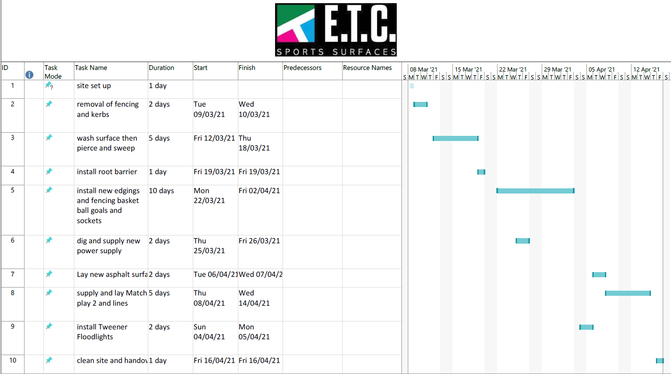
If all goes to plan, then we should have the facility ready to be used by mid to late April.

Club Spark CIA Gate
Our intention is to utilise a specialised gate for the facility that will have a PIN code access. The pin will be provided to each booker of a court. This gate is expensive and so, in partnership with the Tennis Club, we have applied to the Lawn Tennis Association for a grant that will potentially cover the cost. This application has now been completed and we are hopeful for a positive response.

Tennis Club Licence
We have sent the Tennis Club a copy of the proposed contract in December last year and had hoped for their approval by now. I have been informed that other pressing work responsibilities are preventing the leadership team of the tennis club from undertaking this review. The Parish Council is keen to avoid excessive legal fees with chasing letters from our solicitors so we simply will wait until the Tennis Club can perform this task.

