Chairmans report March 2025
The observant among you will have noticed the sheep sculpture on Basil’s Piece, Church Street. This has been placed there in memory of the farming community of Stapleford. From the late 19th Century Stapleford had four substantial farms. Gerald Beavis, Basil Beavis’ brother, farmed at Greenhedge Farm and his sheep used to lamb in the barn which stood at the entrance to what is now Cox’s Close.
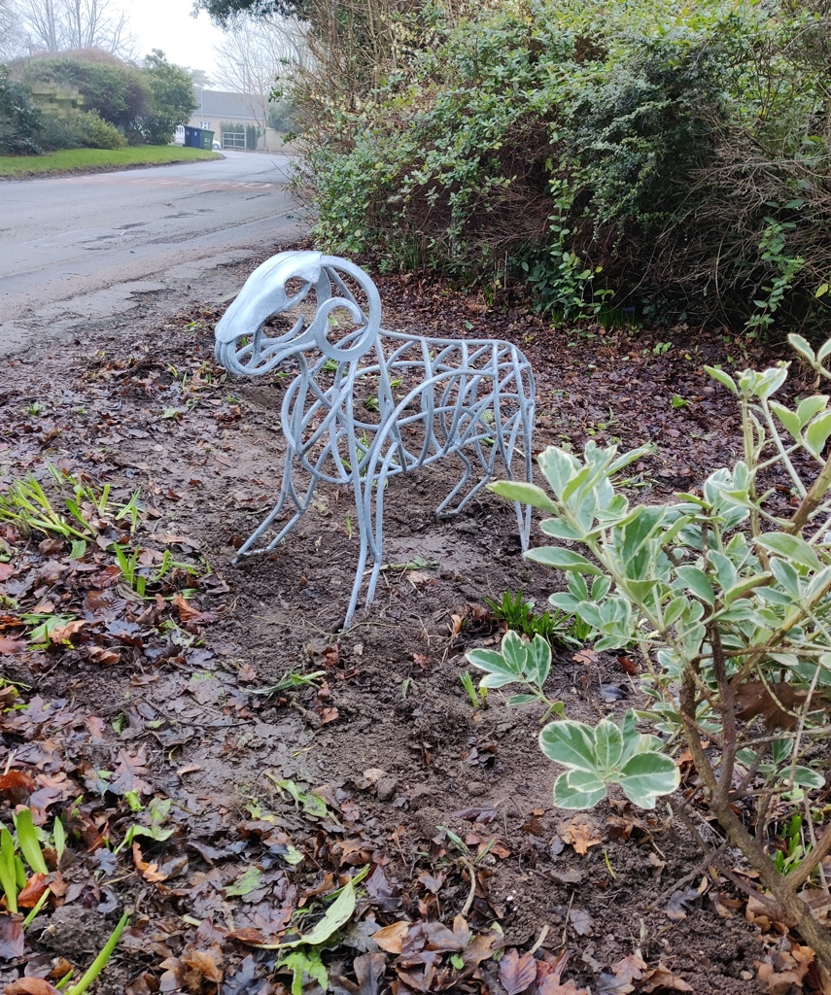

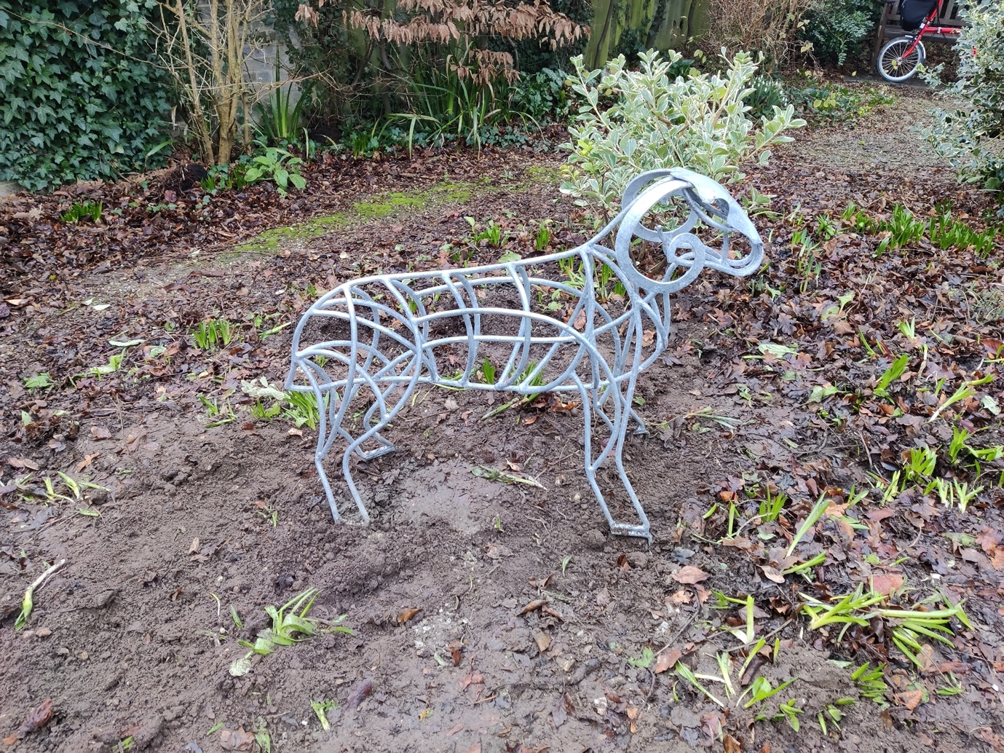

Sawston Greenway was discussed at the Parish Council meeting. Consultation has now closed and work will start soon, starting at the London Road/Church Street junction. Concern was expressed by parishioners that Priam’s Way and Dolphin Way would become a ‘rat run’ for those wishing to avoid this junction. Concern was also expressed at the relocation of the bus stop on London Road. Concerns have been discussed with the project manager.
Stapleford Weekend Terms of Reference, funding and Governance were approved, with the Parish Council giving a commitment to support the weekend with £10,000 for community engagement.
Speed limits along Haverhill Road were discussed and 30mph limit will be sought for the road between the current 30mph limit at the edge of the village to past the entrances to Strawberry Fields, with a shorter 40mph limit following that. Unfortunately, the 20mph limit along the village length of Haverhill Road had been rejected at an earlier application.
Social Media and Safeguarding Policies were approved and will be on the Parish Council website. The Parish Council website will be reviewed and updated.
Consultation on the controversial council 4 day week will have closed by time this is published but District Councillor Will Jackson-Wood attended the meeting and answered questions about this.
Work is progressing on the pavilion renovation but as yet no start date is confirmed, but likely to be at the end of the summer. This will impact regular hirers and occasional hirers as the building and car park will be closed for about 3 months while the work is carried out. Those affected will be informed as soon as a start date is confirmed.
The contract for grounds maintenance has been awarded to Bradgate Grounds Maintenance Ltd and they have now started work looking after the verges, and areas of public land such as the recreation ground, Clerk’s Piece, Basil’s Piece etc.
2G3S are to be thanked for organising a village litter pick at the end of February. A surprising amount of rubbish was collected.
The next meeting of the Parish Council is Thursday 6th April, 7pm in Stapleford Pavilion and members of the public are invited to attend

